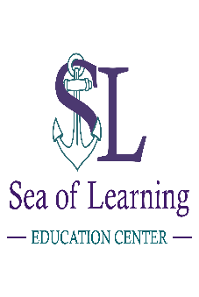 |  | Parent or guardian Learning readiness checklist  Sea of Learning Education Center, LLC  Want an alternative to public school? Look through our checklist to see what your child and you may need for them to be successful. We provide a positive and educational environment where your child can grow and learn according to his or her needs.  - Prices are subject to change
 | 1. Subjects  - Math  - Spelling  - Science  - Social Studies  - Language Arts/Reading  - Writing  - Bible |  |  |  | 6. Tutoring  - $30 per 30 minutes or $45 for 1 hour  - Homework help $30 (3pm-5pm Monday - Friday)
 | 2. Enrollment Fee  - $50 Enrollment/Curriculum Fee  - $30 a week aftercare (2pm-5pm Monday - Friday) |  |  |  | 7. Groups & Clubs Offered  - Kind Kids Club - Garden  - Book Clubs (all age groups) - Life Skills  - Lego - Social Skills  - Crafting - Handwriting  - Spelling Bee  - Games (great for socialization)  - Science/STEM
 | 3. Homeschooling (K-5)  $400 a month  - Curriculum included |  |  |  | 8. Small Groups  $15 per session  or  $200 monthly up to 4 groups per week
 | 4. Elementary Virtual School (K-5)  $250 a month  - Check assignments  - Communicate with Virtual Teacher |  |  |  | 9. Evaluation & Assessments  - Portfolio review $30  - Evaluation/Assessment $50
 | 5. Middle/High Virtual School (6-12)  $200 a month  - Anytime  - Socialization  - Limited monitoring |  |  |  | School hours are:  8am-2pm Monday – Friday  Aftercare hours are:  2pm-5pm Monday - Friday
 |  |  |  |  | Call Today (772) 633-8155

